Server Maintenance & Monitoring Process

Version 1.0

Contents

1. Purpose 5
2. Scope 5
3. Required Technology 6
4. Daily Maintenance & Monitoring Process 7
5. Process: Data backup, restore, and recovery operations 7
Description 7
Purpose 8
Procedure: Configure incremental backup job 8
Dependencies 8
Technology Required 8
Purpose 9
Procedure 1: Verify completion of backup 9
Procedure 2: Report backup problems to incident management 9
Procedure 3: Review the backup log 9
6. Process: Storage resource management 10
Description 10
Purpose 10
Procedure 1: Configure alert 11
Procedure 2: Stop creating share alert 11
Procedure 3: Capacity alert 11
Dependencies 12
Technology Required 12
7. Process: Managing resources and service performance 13
Description 13
Procedure: Create performance monitor logs 13
Dependencies 15
Technology Required 15
8. Process: Verify the Server Status 16
Description: 16
Dependencies 16
Technology Required 16
9. Weekly Maintenance & Monitoring Process 16
10. Process: Data backup, restore, and recovery operations 17
Description 17
Purpose 17
Procedure: Configure normal backup job 17
2. Process: Storage resource management 19
Procedure 1: Analyze the volume 19
Procedure 2: Clean up the volume 20
Procedure 3: Defragment the volume 21
Dependencies 21
Technology Required 21
11. Monthly Maintenance & Monitoring Process 22
1. Process: Reviewing configuration items 22
Description 22
Purpose 22
Procedure 1: Run Srvinfo for all file servers 22
Procedure 2: Export local security polices 22
Procedure 3: Create report of installed software 23
Procedure 4: Create report of installed hotfixes 24
Dependencies 24
Technology Required 24
12. 2. Process: Patch Update Proess 24
Contact Us 30

Document Information
This Document describes some of the items that you should check on a daily basis to help monitor the status of a Windows Server system. You must perform most of these checks consistently and archive the results over a period of time to obtain the greatest benefit

Purpose
Purpose of this document is to provide the steps involved in performing monthly maintenance checks of the reliability, administration, security, and performance of a Windows Server system

- Minimize disruption to the Client Access environment
- Maintain system performance
- Minimize administrative overhead
- Maximize "quick wins"
- Maintain system security

Scope
Scope is written below.

Daily Maintenance Guideline
Weekly Maintenance Guideline
Monthly Maintenance Guideline
Support

Required Technology

Table 1 lists the tools or technologies used in the procedures described in this guide. All tools should be accessed from a Windows Server 2003 server console, except in those cases where a link is provided. All tools should be accessed from a Windows Server 2003 server console, except in those cases where a link is provided.

Required Technology | Description | Location
Disk Defragmenter | Tool used to analyze volumes for fragmentation. Also used to defragment volumes. | Start > All Programs > Accessories > System Tools > Disk Defragmenter
System Monitor (formerly known as Performance Monitor) | Tool used to collect data on server health and performance | Start > All Programs > Administrative Tools > System Monitor
Event Viewer | Tool used to monitor and gather information on system, security, and application events | Start > All Programs > Administrative Tools > Event Viewer
Quota Entries window | To be used to view and configure quotas on a volume | On the properties page of a NTFS volume
Disk Cleanup | Tool used to remove temporary files, Internet cache files, and unnecessary program files | Start > All Programs > Accessories > System Tools > Disk Cleanup
Backup | Tool used to perform backup and restore operations | Start > All Programs > Accessories > System Tools > Backup

Recommended Technology | Description | Location
Srvinfo.exe | Tool used to gather system information from servers | Windows Server 2003 Resource Kit
Volperf.exe | Tool used to install performance objects and counters for volume shadow service | Windows Server 2003 Resource Kit
Fsutil.exe | Tool used to manage Windows® file system | \Winnt\System32

-

Daily Maintenance & Monitoring Process

This Section provides detailed information about the processes that must be performed in order to maintain Windows Server 2003 .
Check Lists Detail | Check  (Y/N)
To be checked Daily
Check event log of every server, fix/try to fix as needed | Y/N
Make sure backup runs and verify the files | Y/N
Check for free space on all servers, for file pollution and quotas. | Y/N
Ensure that all server services are running | Y/N
Ensure that anti-virus definitions are up-to-date. | Y/N
Keep Service Pack and Hot fixes current. | Y/N
Chcek Network connectivity and DNS name resolution | Y/N
Check Applications Running | Y/N

Process: Data backup, restore, and recovery operations

Description
Backing up, restoring, and recovering data are key storage management activities for maintaining company data. Data should be classified by type, and a strategy should be developed to ensure that those processes fulfill business requirements and service level objectives.
Task: Run daily incremental backup

Purpose
Performing regularly scheduled backups is an integral part of any file service operations environment. A good backup strategy should include daily incremental or differential backups as well as weekly backups. Numerous strategies exist regarding the frequency and types of backup jobs that an operations team can implement.

Procedure: Configure incremental backup job
1. Start Backup utility and select the Backup tab.
2. Select the drives, folders, and files that will be included in the backup. It is a good idea to include the system state information as part of the backup operation.
3. On the Tools menu, click Options. In the Options window, on the Backup Log tab, select Detailed, and click OK.
Backup logs can be vital to troubleshooting and recording status of the backup operation. The default setting in Windows Server 2003 is for backup logs to contain such summary information as loading a tape, starting the backup, backing up files, backing up bytes, or failing to open a file. Some operations environments require more detail information—specifically, what files are being backed up for a particular backup job.
4. On the Tools menu, click Options. In the Options window, click the Backup Type tab. In the Default Backup Type drop-down list, select Incremental, and click OK.
5. In Backup Destination, select one of the following:
● Choose file to back up files and folders to a file. This is the default setting.
● Choose a tape device if you want to back up files and folders to a tape.
6. In Backup media or file name, select one of the following:
● If you are backing up files and folders to a file, enter the path and file name of the backup (.bkf) file.
● If you are backing up files and folders to tape, choose the tape you want to use.
7. Click Start Backup, then click Advanced, select Data Verification, and click OK.
8. Click Schedule and enter the logon name and password that the backup will run as, and then click OK. In the Schedule Job Options window, enter the name for the backup job—for example, "ServerName-IncBackup-Date," and click OK.
9. In the Schedule Job window, confirm that the Schedule tab is selected. Under Schedule Task, select Weekly and click the days of the week you want the incremental job to run. In Start time, enter the time you want the backup to start and click OK.
10. Enter the logon name and password that the backup job will run as and then click OK. Click OK again to exit the window.

The daily incremental job is now scheduled to run.

Dependencies
None

Technology Required
Backup.exe

Task: Verify previous day’s backup job

Purpose
This task provides guidance on verifying the integrity of the daily scheduled backup. Regardless of the utility used to provide backup service to the file server, the operations team should verify each backup job after its completion. This verification allows the operations team to resolve issues concerning backups that may put the organization at risk of data loss.

Procedure 1: Verify completion of backup
You can use Event Viewer to verify whether a backup started and completed, and if any errors were encountered during the backup operation.
1. Start Event Viewer.
2. Right-click Application Log, and click Properties, highlight View, and select Filter.
3. In Event Source, click the drop-down menu, select Backup, and click OK.
4. Search for the following events:

● Event 8000. This event signals the start of a backup on a volume. You should receive this event for each volume in the backup job.
● Event 8001. This event signals the end of a backup on a volume. You should receive n-1 of this event for a backup job, where n is equal to the number of volumes in the backup job. When a volume has been backed up successfully, Event 8001 will be logged as an informational event. When errors are encountered backing up a volume, Event 8001 will be logged as an error event.
● Event 8019. This event signals the end of the backup operation. You should receive one 8019 event per backup job.

Procedure 2: Report backup problems to incident management
Use your organization's incident management process to record the following conditions in your environment. This procedure describes some of the steps that should be followed when filling out the incident management report.
1. Event 8000 is not logged in the application log. When this occurs, the file server is at risk of data loss. Verify that the backup job has not been deleted. Review the start time for the job to verify that it has not been modified.
2. Event 8000 is not logged for all volumes on the server. When this occurs, a volume is at risk of data loss. Review the backup configuration for the backup job to see if the volume has been removed from the backup job. Check the configuration management database (CMDB) to see if the volume has been removed from the backup job.
3. Event 8001 is logged as a warning event in the application log. Review the backup log by searching for the "Warning:" string in the body of the log. Record what the warning is and the reason for the warning.
4. Event 8019 is not logged in the application log. This means the backup job is still running. Review the application log and record the last volume to trigger a successful 8001 informational event. Record the last volume to trigger an 8000 event.

Procedure 3: Review the backup log
Backup logs can be vital for troubleshooting and recording status of the backup operation. The default setting in Windows Server 2003 is for backup logs to contain summary information such as loading a tape, starting the backup, and backing up files, backing up bytes, or failing to open a file. Some operations environments require more detailed information—specifically, what files are being backed up for a particular backup job.
To get more detailed logging in the backup logs
1. Start the Backup utility.
2. On the Tools menu, click Options.
3. In the Options window, click the Backup Log tab, select Detailed, and click OK.

Backup logs will now contain detailed information regarding the backup operations.
To review the backup log
1. Start Backup utility.
2. On the Tools menu, click Reports.
3. In the Backup Report dialog box, select the previous night’s backup report, and click View.

Process: Storage resource management

Description
Storage resource management (SRM) is a key storage management activity that ensures that important storage devices, such as disks, are formatted and installed with appropriate file systems.
In addition, SRM includes using management technologies to monitor storage resources in order to ensure that they meet availability, capacity, and performance requirements.
Task: Monitor available disk space

Purpose
This task proactively monitors disk space on a volume to control the allocation of disk space and to provide reporting for capacity planning. It mitigates any problems that may result in rapid file growth on a volume.
In an IT environment, it is important to set alerts on a logical volume at differing capacity levels. Some alerts are informational so that the status of the disk volume can be reported. Other alerts are used to warn the operations team of a real problem with capacity on a volume. The following are suggested thresholds on a volume:
● Sixty-five percent capacity. It is important to note that a particular volume is at 65 percent or more full. This means that volume has only 35 percent or less capacity for growth.
● Seventy-five percent capacity. When a volume is 75 percent full, consider creating new shares on another volume.
● Ninety percent capacity. Volumes that are at 90 percent capacity should not have file shares created on them. Volumes that are at 90 percent should be included in the problem management report.
Once the 90 percent capacity threshold is reached and an alert is generated, an administrator should initiate appropriate changes such as increasing available capacity, or begin to migrate the shares to higher-capacity subsystems. Additional administrative actions might include performing disk defragmentation and disk cleanup. (See Task: Review Disk Fragmentation.)

Procedure 1: Configure alert
1. Start System Monitor.
2. Expand the Performance Logs and Alerts node, right-click Alerts, and click New Alert Settings.
3. Type Jobs Spooling and click OK.
4. On the General tab, click Add, and select the following object, instance, and counter:
Object | Instance | Counter
Logical Disk Space | Each Logical Volume Instance. | % Free Space
5. In the Alert when the value is drop-down box, select Over and enter the limit for your environment.
6. On the Action tab, the default selection is Log an entry in the application event log.
7. Select the Schedule tab, click Start Log At, and enter the start time for the alert.
8. Click Apply, and then click OK.

The alert is activated and will have a green status indicating that it is logging information based on the configuration and schedule.

Procedure 2: Stop creating share alert
● Review the event log for Event 2031:

Event Type: Information
Event Source: SysmonLog
Event Category: None
Event ID: 2031
Description:
Counter: \\Servername\LogicalDisk(driveletter)\% Free Space has tripped its alert threshold. The counter value of n is under the limit value of n.

When you begin to receive Event 2031, the capacity of the volume must be included in the daily problem management report. This alert can indicate when to stop creating new shares on a volume. The remaining space on the volume is used to accommodate data growth on existing shares.
This alert will continue be written to the application log until the alert is stopped. It is okay to stop the alert, but once a volume has triggered the Stop Creating Share alert, the capacity should always be included in the daily problem management report.

Procedure 3: Capacity alert
● Review the event log for Event 2031. (See Procedure 2: Stop creating share alert.) Once the capacity alert is triggered, the disk has reached capacity. The alert should be set as 20-25 percent free space. Once a volume has triggered the capacity alert, submit a request for change (RFC) to move data to another volume or to extend the volume.

Dependencies
An alert must be configured to perform an action when a certain disk capacity threshold is reached.

Technology Required
Performance Logs and Alerts in Windows Server 2003

Process: Managing resources and service performance

Description
Capacity management is concerned with optimizing the use of IT resources in order to achieve the level of service performance agreed upon with the client. These resources are supplied by support organizations to ensure that the requirements of the business are met. The capacity management process can be either reactive or proactive. Iterative activities, such as monitoring, analyzing, tuning, and reporting, are also important in the process of managing resources and service performance. Each process requires different types of data. For example, managing IT resources involves documenting the usage levels of individual components in the infrastructure, whereas managing service performance records transaction throughput rates and response times.
Task: Capture service performance statistics
Purpose
During the normal operation of a file server, it is important to monitor the overall health of the server. This information will be used to review general performance, adherence to service level agreements (SLAs), and capacity planning and to create a baseline for the file server.

Procedure: Create performance monitor logs
1. Start System Monitor.
2. Double-click Performance Logs and Alerts, right-click Counter Logs, and select New Settings.
3. Enter the name for this log—for example, "Service Performance Statistics"—and click OK.
4. On the General tab, click Add Counters and select the following counters:

Processor Performance | Notes
Processor\% Processor Time | The percentage of elapsed time the processor spent executing instructions for processes or services. It reports the sum of the time the processors spent executing code in privileged mode and executing code in user mode. This counter provides an overall view of the processors' activity.
Processor\% Privileged Time | The percentage of elapsed time that the process threads spent executing code in privileged mode. The operating system switches application threads to privileged mode to allow direct access to the system’s kernel.
System\Context Switches/sec | The combined rate at which all processors on the computer are switched from one thread to another. Context switches occur when a running thread voluntarily relinquishes the processor, is preempted by a higher priority ready thread, or switches between user mode and privileged mode to use an executive or subsystem service. High rates of context switching can result from inefficient hardware or poorly designed device drivers or applications.
Memory Performance | Notes
Memory\Pages/sec | Pages/sec is the rate at which pages are read from or written to the disk in order to resolve hard page faults. This counter is a primary indicator of the kinds of faults that cause system-wide delays.
Memory\Available megabytes (MB) | Available megabytes is the amount of physical memory, in megabytes, immediately available for allocation to a process or for system use.
Paging File\% Usage | The amount of the page file instance in use in percent.
Network Performance | Notes
Server\Error System | The number of times an internal server error was detected. Unexpected errors usually indicate a problem with the server.
Server\Work Item Shortages | This occurs when no work item is available or can be allocated to service the incoming request. A work item is the location where the server stores a server message block (SMB). Work item shortages might be caused by an overloaded server.
Server\Blocking Requests Rejected | The number of times the server has rejected blocking SMBs due to insufficient count of free work items. This counter indicates whether the MaxWorkItem or MinFreeWorkItems server parameters might need to be adjusted.
Server Work Queues\Queue Length | Queue length is the current length of the server work queue for this CPU. A sustained queue length greater than four might indicate processor congestion. This is an instantaneous count, not an average over time.
Disk Performance | Notes
Physical Disk\Current Disk Queue Length | Current disk queue length is the number of requests outstanding on the disk at the time the performance data is collected. It also includes requests in service at the time of the collection. This is an instantaneous snapshot, not an average over time interval. Multi-spindle disk devices can have multiple requests that are active at one time, but other concurrent requests are awaiting service.  This counter might reflect a transitory high or low queue length, but if there is a sustained load on the disk drive, it is likely that this will be consistently high. This counter requests experience delays proportional to the length of this queue minus the number of spindles on the disks. For good performance, this difference should average less than two.
Physical Disk\Avg. Disk sec/read | Avg. Disk sec/read is the average time, in seconds, of a data read from the disk.
Disk Performance | Notes
Physical Disk\Disk read bytes/sec | Disk read bytes/sec is the rate at which bytes are transferred from the disk during read operations.
Physical Disk\Disk write bytes/sec | Disk write bytes/sec is the rate at which bytes are transferred to the disk during write operations.
Physical Disk\Disk read/sec | Disk read/sec is the rate of read operations on the disk.
Physical Disk\Disk write/sec | Disk write/sec is the rate of write operations on the disk.

5. Fifteen is the default sampling interval. You can modify this number. Increasing the interval will reduce the size of the log file but at the risk of losing data. Decreasing the interval will increase the size of the log file and provide a more detailed look at the performance.
6. On the Log Files tab, click the Log File Type drop-down box and select the output format. Choose a CSV file type if you want to be able to manipulate the data in Excel. The data can also be written to an SQL database format.
7. Make sure the End File Names checkbox is checked. Use the year, month, and day format yyyymmdd.
8. On the Schedule tab, click the Start Log At checkbox, and enter the start time for logging.
9. Click the Stop Log At checkbox and enter the time at which logging should stop.
10. Click Apply, and then click OK. The log files will be created in <system drive>\Perflogs by default.

The log is activated and will have a green status, indicating that it is logging information based on the configuration and schedule.

Dependencies
● you must be a member of the administrators group or the performance log users group on the local computer, or have been delegated the appropriate authority.
● there must be adequate space on the disk where the log files are being created.

Technology Required
System Monitor

Process: Verify the Server Status

Description:
These steps should be followed when the status of a server is reported as offline.

Task: Check status of Server

1. Run the PING utility from the command line or attempt connection using Terminal Service, or mounting an administrative share such as C$, to verify that the offline server can receive network communication. If this test fails, escalate the issue to the problem management team to get the server online.
2. Run Srvinfo.exe using the following command to make sure all the proper services are running srvinfo\\<servername>, where servername is the server reported as offline.
3. Log on to the server locally or over the network. Verify that you can log on to the server.

Dependencies
● Network connectivity should be available

Technology Required
● Srvinfo.exe

Weekly Maintenance & Monitoring Process

Check Lists Detail | Check  (Y/N)
To be checked Weekly
Clean Servers, check for .tmp files, jetdb files, etc. | Y/N
Uptime/Downtime reports | Y/N
Performance Monitoring/Capacity Planning | Y/N
Take Full backup of server | Y/N
Ensure that anti-virus definitions are up-to-date. | Y/N
Keep Service Pack and Hot fixes current. | Y/N
Check Network connectivity and DNS name resolution | Y/N
Check Applications Running | Y/N

Process: Data backup, restore, and recovery operations

Description
Storing, restoring, and recovering data are key storage management activities for maintaining company data. Data should be classified by type, and a strategy should be developed to ensure that backup and recovery processes fulfill business requirements and service level objectives.
Task: Run weekly normal backup

Purpose
Performing regularly scheduled backups is an integral part of any file service operations environment. A good backup strategy should include daily incremental or differential backups as well as weekly backups. Numerous strategies exist regarding the frequency and types of backup jobs that an operations team can implement.

Procedure: Configure normal backup job
- Click Start->Run and type ntbackup
- Click the Advanced Mode link
- Click Backup Wizard (Advanced)
- Click Next
- Make sure Back up everything on this computer is selected and click Next
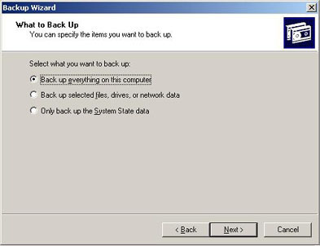
- We will backup to a file, you can place it wherever you want, just make sure you name it Appropiatly and click Next
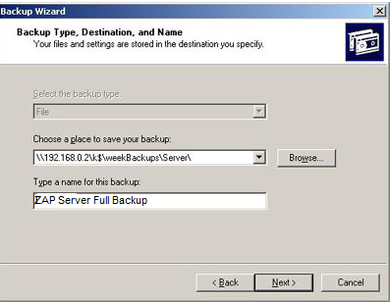
- Click Advanced
- Make sure Normal is selected as type of backup and click Next
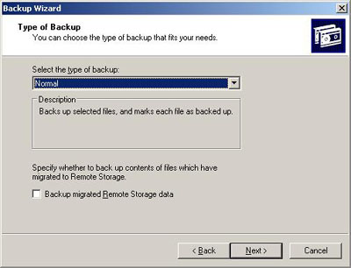
7. Click Start Backup, click Advanced, select Data Verification, and click OK.
8. Click the Schedule, enter the logon name and password that the backup job will run as, and then click OK.
9. In the Schedule Job Options window, enter the name for the backup job, such as "Increment Backup," and click OK.
10. In the Schedule Job window, confirm the Schedule tab is selected. Under Schedule Task, select Weekly and click the days of the week you want the incremental job to run. In Start Time, enter the time you want the backup job to start, and click OK.
11. Enter the logon name and password that the backup job will run as and then click OK.
12. Click OK.

The weekly normal job is now scheduled to run.
Dependencies
None
Technology Required
Backup.exe

2. Process: Storage resource management
Description
Storage resource management (SRM) is a key process for ensuring that important storage devices, such as disks, are formatted and installed with appropriate file systems.
In addition, SRM includes using management technologies to monitor storage resources to ensure that they meet availability, capacity, and performance requirements.
Task: Review disk fragmentation
Purpose
Disk fragmentation occurs when files are written to non-adjacent clusters on a disk. During normal operations of a file server, the file system will become fragmented. Fragmentation has a performance effect on the read/write action. A disk that is highly fragmented requires several passes of the disk’s read and write heads to retrieve or store data to the disk.
To analyze the extent of disk fragmentation on a volume and to remediate performance issues associated with fragmented files and free space, run the Disk Defragmenter utility. An effective use of the Disk Defragmenter utility should include removing unnecessary files from the volume. Prior to defragmenting a volume, run the Disk Cleanup utility to perform the following activities:
● Remove temporary Internet files.
● Remove any downloaded program files (for example, Microsoft ActiveX® controls and Java applets downloaded from the Internet).
● Empty the Recycle Bin.
● Remove Windows temporary files.
● Remove Windows components that you are not using.
● Remove installed programs that you no longer use.

Procedure 1: Analyze the volume
1. Start Disk Defragmenter.
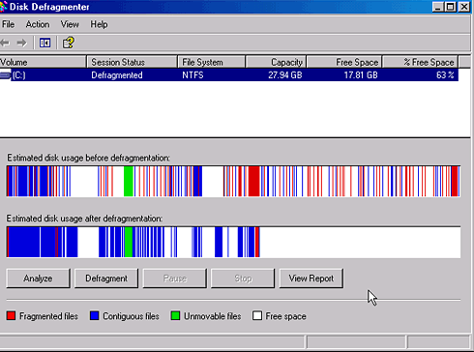
2. Select the volume that you want to analyze, and then click Analyze.
3. Click Save As to save the report.

Procedure 2: Clean up the volume
1. Start Disk Cleanup.
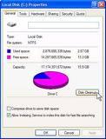
2. Select the volume that was analyzed in Procedure 1.
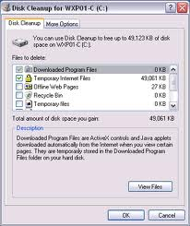
3. Select the file types to delete and click OK.

Procedure 3: Defragment the volume
1. Start Disk Defragmenter.
2. Click the volume that you want to defragment, and then click the Defragment button.
You can use Defrag.exe to schedule defragmentation on a volume. It is best to defragment a volume during low usage periods in order to reduce the effect the process has on file server performance. The syntax for the command line is:
defrag <volume> -v >filename.txt
where volume is the drive you want to defragment, and filename is the name of the file that will contain the defragmentation report. For a list of switches for the Defrag command, at the command prompt, type defrag.

Dependencies
● Administrator privileges are required to run Disk Defragmenter.
● Defragmentation requires 15 percent free disk space. If there is low disk space, consider using the –f switch. This switch forces defragmentation even if free disk space is low.
● Confirm that there is a good backup of the volume prior to performing defragmentation.
● For more information on running Disk Cleanup from the command line, see the Automating Disk Cleanup Tool in Windows white paper available at http://support.microsoft.com/default.aspx?scid=kb;EN-US;253597.
● Disk Defragmenter cannot be run on a volume that has Volume Shadow Copies activated. For more information, see the Shadow Copies May Be Lost When You Defragment a Volume white paper available at http://support.microsoft.com/default.aspx?scid=kb;en-us;312067.

Technology Required
● Disk Defragmenter
● Disk Cleanup

Monthly Maintenance & Monitoring Process

Check Lists Detail | Check  (Y/N)
To be checked Monthly
Change Service Account Passwords | Y/N
Extended testing backups with restores | Y/N
Performance Monitoring/Capacity Planning | Y/N
Take Full Monthly backup of server | Y/N
Ensure that anti-virus definitions are up-to-date. | Y/N
Apply Service Pack and Hot fixes current. | Y/N
Run defrag and chkdsk on all drives | Y/N
Audit the Installed Application , Configuration Changes etc | Y/N

1. Process: Reviewing configuration items

Description
Because the accuracy of the information stored in the configuration management database (CMDB) is crucial to the success of Change Management, Incident Management, and other SMFs, a review process should be set up to ensure that the database accurately reflects the production IT environment.
Task: Capture configuration snapshot

Purpose
This task configures the file server to provide a point-in-time view of the file server.

Procedure 1: Run Srvinfo for all file servers
To get system information, shared folders, disk capacity, services currently running, network protocols, and system uptime use Srvinfo.exe.
At the command line run:
srvinfo –s \\<servername .><drive path>:\servername-date.txt
Srvinfo is scriptable and can be easily automated to facilitate batch processing for large environments.

Procedure 2: Export local security polices
1. Start Local Security Policies MMC and expand the Local Policies node.
2. Highlight Audit Policy, then right-click and select Export List. Save the export to a secure file share.
3. Highlight User Right Assignment, then right-click and select Export List. Save the export to a secure file share.
4. Highlight Security Options, then right-click and select Export List. Save the export to a secure file share.

Procedure 3: Create report of installed software
The following sample script can be used to create a report of the software installed on the file server using Windows Installer. SMS is a good alternative to enumerate installed applications, window components, and patches. This is especially useful for large in environments.

Set objFSO = CreateObject("Scripting.FileSystemObject")
Set objTextFile = objFSO.CreateTextFile("filename", True)
strComputer = "."
Set objWMIService = GetObject("winmgmts:" _
& "{impersonationLevel=impersonate}!\\" & strComputer & "\root\cimv2")
Set colSoftware = objWMIService.ExecQuery _
("Select * from Win32_Product")
objTextFile.WriteLine "Caption" & vbtab & _
"Description" & vbtab & "Identifying Number" & vbtab & _
"Install Date" & vbtab & "Install Location" & vbtab & _
"Install State" & vbtab & "Name" & vbtab & _
"Package Cache" & vbtab & "SKU Number" & vbtab & "Vendor" & vbtab _
& "Version"
For Each objSoftware in colSoftware
objTextFile.WriteLine objSoftware.Caption & vbtab & _
objSoftware.Description & vbtab & _
objSoftware.IdentifyingNumber & vbtab & _
objSoftware.InstallDate2 & vbtab & _
objSoftware.InstallLocation & vbtab & _
objSoftware.InstallState & vbtab & _
objSoftware.Name & vbtab & _
objSoftware.PackageCache & vbtab & _
objSoftware.SKUNumber & vbtab & _
objSoftware.Vendor & vbtab & _
objSoftware.Version
Next
objTextFile.Close

This sample script may produce an error if there are no MSI installed applications.

Procedure 4: Create report of installed hotfixes
The following sample script can be used to create a report of the software installed on the file server using the Windows Installer:

strComputer = "."
Set objWMIService = GetObject("winmgmts:" _
& "{impersonationLevel=impersonate}!\\" & strComputer & "\root\cimv2")
Set colQuickFixes = objWMIService.ExecQuery _
("Select * from Win32_QuickFixEngineering")
For Each objQuickFix in colQuickFixes
cscript.Echo "Computer: " & objQuickFix.CSName
cscript.Echo "Description: " & objQuickFix.Description
cscript.Echo "Hot Fix ID: " & objQuickFix.HotFixID
cscript.Echo "Installation Date: " & objQuickFix.InstallDate
cscript.Echo "Installed By: " & objQuickFix.InstalledBy
Next

Dependencies
MSI installed software

Technology Required
● Srvinfo.exe
● Local security policies
● Windows Management Instrumentation (WMI)

2. Process: Patch Update Proess
Creating an offline update CD is a great way to update a Windows computer without having to connect it to the Internet and risk the chance of it being compromised
Step 1: Download and extract Offline Update.
Step 2: Run “UpdateGenerator.exe” and select the products you wish to create an offline update CD for.. You can also select the type of ISO file you want to create under “Create ISO image(s)”. You can create an ISO per product and language or one large “cross-product” DVD for all multiple operating systems. Click “Start” to download updates and create the ISO file.
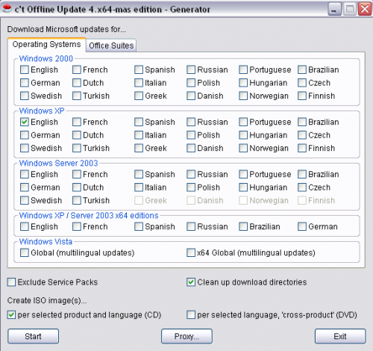

Step 3: When Offline Update is finished, navigate to your “iso” folder under the directory you extracted the Offline Update program to. Depending on the ISO selection you made, you will either see an ISO file per product or one large ISO file for all products. Burn the ISO file to a CD or DVD.
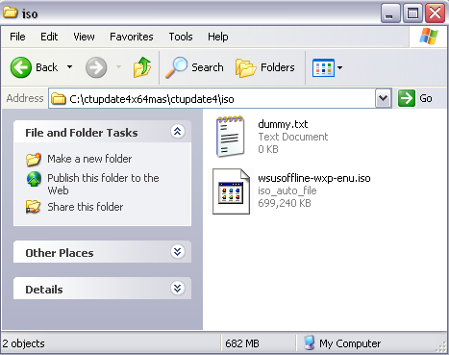

Step 4: Put the CD or DVD into the computer you wish to update. The update installer should auto run. If it doesn’t, navigate to the CD and run “UpdateInstaller.exe”. Choose “Automatic reboot and recall” to have the computer automatically restart the update process after a reboot caused by an update. This option makes the update process fully automated. Offline Update also gives you the option backup your system files or to install Internet Explorer 7. When you are ready to begin the update process click “Start”.
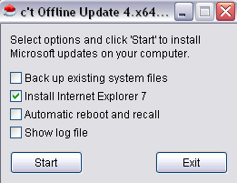
Offline Update will now scan the computer to see which updates are needed and will only install them if they are. If you have any experience with Offline Update or any other types of update utilities please feel free to share.

Document Change History

Table 1: Document Change History
Version Number | Description of Changes | Author | Comments
1.0 | Security Implementation Document
Source: Comviva

Restrictions and Copyright Declaration
The information in this document is subject to change without notice and describes only the product defined in the introduction of this documentation. This document is intended for the use of prospective Comviva Technologies Limited customers for the sole purpose of the agreement under which the document is submitted. No part of it may be reproduced or transmitted in any form or means without the prior written permission of Comviva Technologies Limited. The intended audience for this document is professional personnel, who assume full responsibility for using the document appropriately. Comviva Technologies Limited welcomes customer comments as part of the process of continuous development and improvement of its documentation. The information or statements given in this document concerning the suitability, capacity, or performance of the mentioned hardware or software products cannot be considered binding, but shall be defined in contextual specific eventual agreement made between Comviva Technologies Limited and the customer.
However, Comviva Technologies Limited has made all reasonable efforts to ensure that the instructions contained in the document are adequate, sufficient and free of material errors and omissions. Comviva Technologies Limited will, if necessary, explain issues, which may not be covered by the document. Comviva Technologies Limited’s liability for any errors in the document is limited to the documentary correction of errors. Comviva Technologies Limited will not be responsible, in any event, for errors in this document or for any damages, incidental or consequential, including monetary losses that might arise from the use of this document or the information in it.
This document and the product it describes are considered protected by Patent, Copyright and Trademark laws in accordance with relevant Indian laws.
The only warranties for Comviva Technologies Limited products and services are set forth in the express warranty statements accompanying its products and services. Nothing herein should be construed as constituting an additional warranty. Comviva Technologies Limited shall not be liable for technical or editorial errors or omissions contained herein.
Comviva logo is a registered trademark of Comviva Technologies Limited. Other product names mentioned in this document may be trademarks of their respective companies and they are mentioned for identification purposes only.
Copyright © 2009 Comviva Technologies Limited. All rights reserved.

Copyright © 2010 Comviva Technologies Limited. All rights reserved.

